YASH RAJ

24K-0737

HEALTHY LIFESTYLE

A GOOD START TO HEALTHY LIFESTYLE

Table of Contents

1. Introduction  
2. Key Components of a Healthy Lifestyle  
3. Benefits  
4. Conclusion  
5. References

# Introduction

A healthy lifestyle involves balancing physical activity, nutrition, mental well-being, and proper rest. This report outlines the importance of maintaining such a lifestyle for overall well-being.

# Key Components of a Healthy Lifestyle

1. Regular Physical Activity  
2. Balanced Diet  
3. Adequate Sleep  
4. Stress Management

# Benefits of a Healthy Lifestyle

Maintaining a healthy lifestyle has numerous benefits, including:  
- Reduced risk of chronic diseases  
- Improved mental health  
- Enhanced physical fitness  
- Better sleep quality

# Conclusion

Adopting and maintaining a healthy lifestyle is essential for long-term health and well-being. By making small adjustments in daily habits, individuals can enjoy a more balanced and fulfilling life.

|  |  |
| --- | --- |
|  |  |
| Exercise | 30 |
| Sleep | 480 |
| Work | 480 |
| Leisure | 150 |

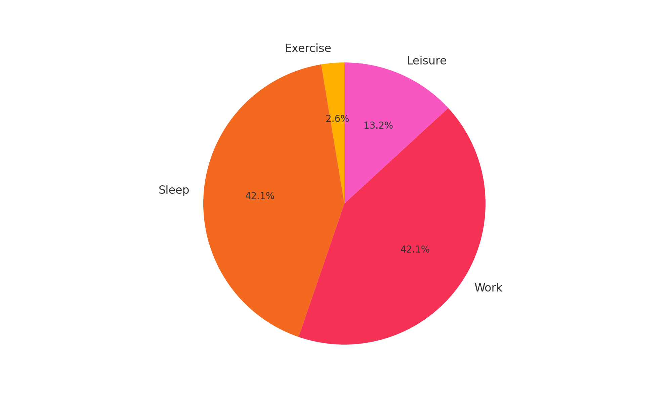

# References

World Health Organization. (2023). Healthy Living. WHO.

Harvard School of Public Health. (2022). Healthy Lifestyle Choices.